[**DIGITAL SIGNAL & IMAGE PROCESSING LAB**](https://github.com/Amey-Thakur/DIGITAL-SIGNAL-AND-IMAGE-PROCESSING-AND-DIGITAL-SIGNAL-AND-IMAGE-PROCESSING-LAB)

[**EXPERIMENT -**](https://github.com/Amey-Thakur/DIGITAL-SIGNAL-AND-IMAGE-PROCESSING-LAB) **6**

**PART B**

(PART B: TO BE COMPLETED BY STUDENTS)

***(Students must submit the soft copy as per the following segments within two hours of the practical. The soft copy must be uploaded on the Blackboard or emailed to the concerned lab in charge faculties at the end of the practical in case there is no Blackboard access available)***

| **Roll No. 50** | **Name: AMEY THAKUR** |
| --- | --- |
| **Class: COMPS-BE-B-50** | **Batch: B3** |
| **Date of Experiment: 01/09/2021** | **Date of Submission: 01/09/2021** |
| **Grade :** |  |

**A.1 Aim:**

Write a program to Implement Image Negative, GrayScale Slicing and Thresholding.

**B.1 Software Code written by a student:**

***(Paste your code completed during the 2 hours of practice in the lab here)***

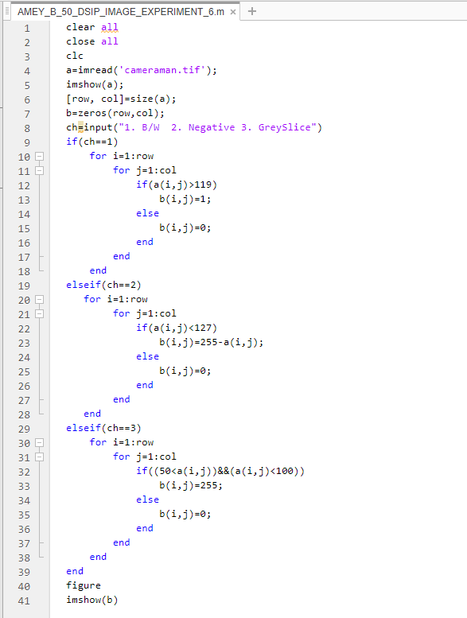

**B.2 Input and Output:**

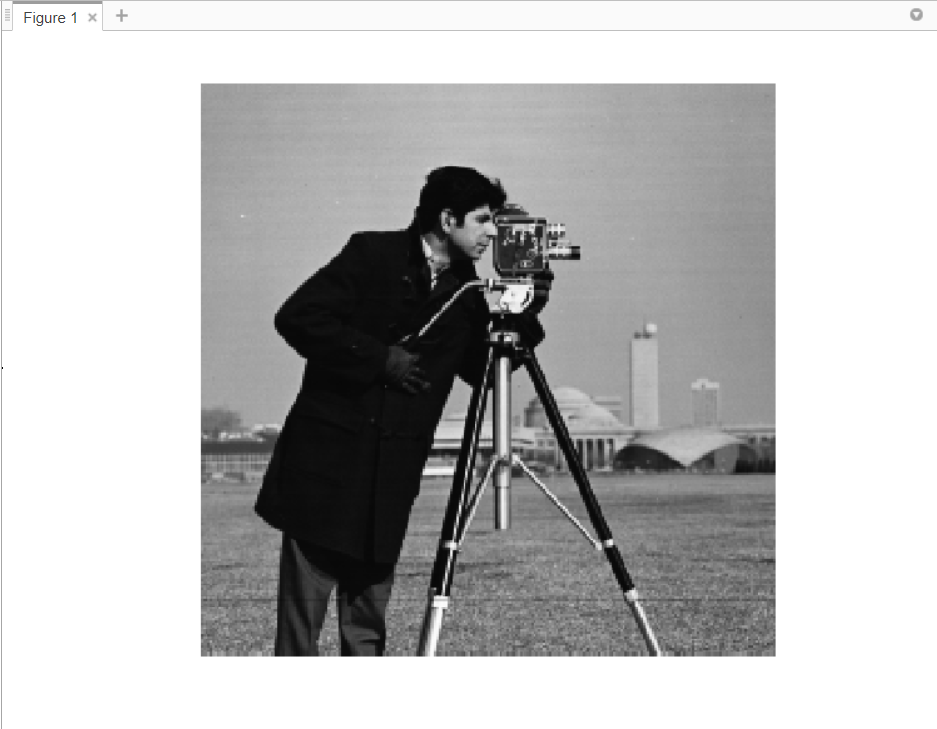

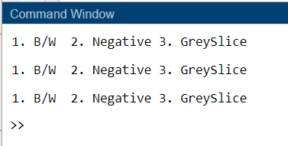

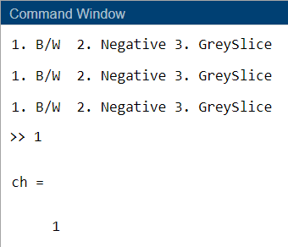

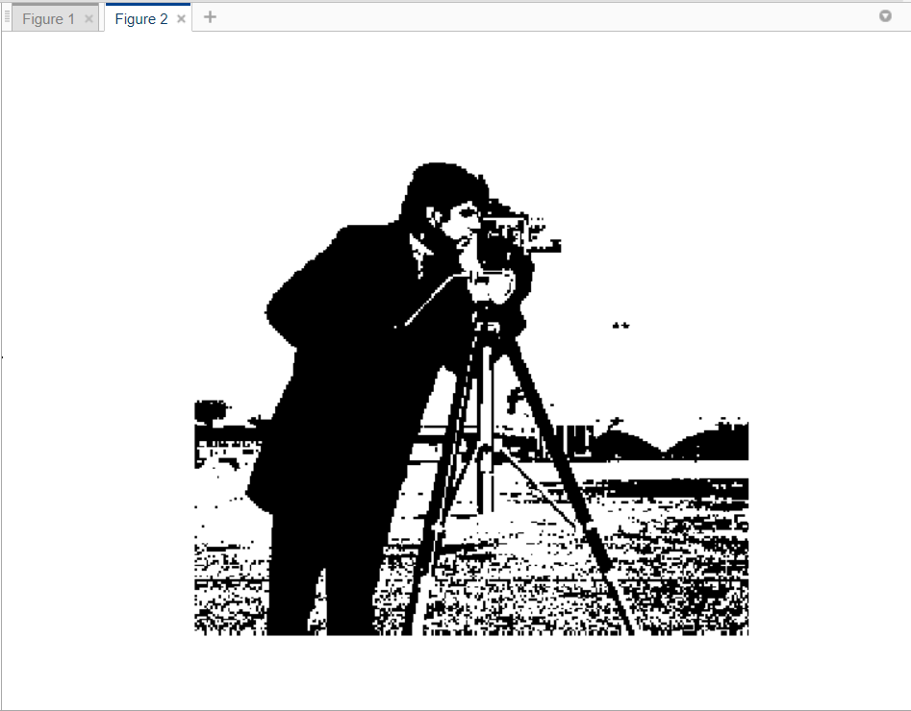

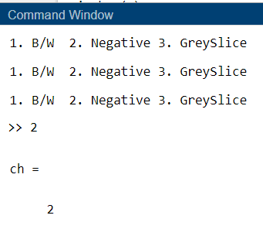

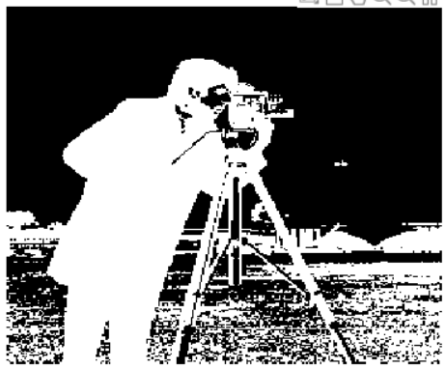

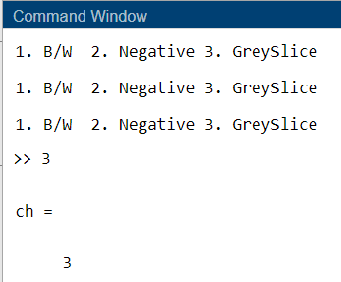

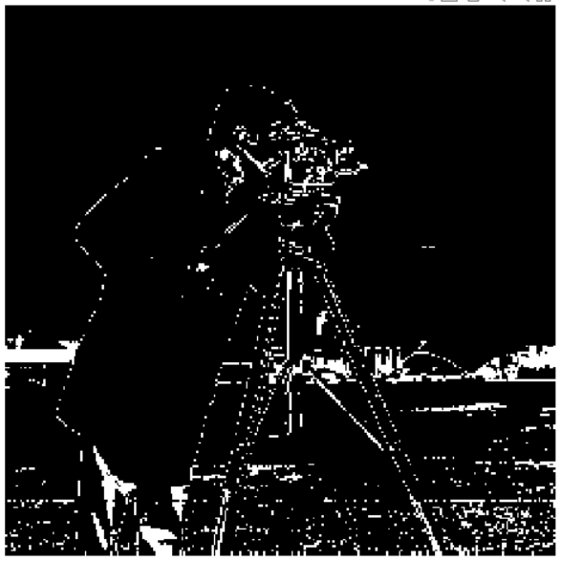

**B.3 Observations and learning:**

***(Students are expected to comment on the output obtained with clear observations and learning for each task/ subpart assigned)***

We implemented spatial domain Image enhancement techniques.

**B.4 Conclusion:**

***(Students must write the conclusion as per the attainment of individual outcome listed above and learning/observation noted in section B.3)***

As a result, we developed a programme that implements Image Negative, GrayScale Slicing, and Thresholding.

**B.5 Question of Curiosity:**

***(To be answered by student based on the practical performed and learning/observations)***

1. What is Gray Level Slicing?

Ans:

Grey level slicing is equivalent to band pass filtering. It manipulates groups of intensity levels in an image up to a specific range by diminishing rest or by leaving them alone. This transformation is applicable in medical images and satellite images such as X-ray flaws, CT scan. The grey level or grey value indicates the brightness of a pixel. The minimum grey level is 0. The maximum grey level depends on the digitisation depth of the image. In contrast, in a greyscale or colour image a pixel can take on any value between 0 and 255.

1. What are the Image Transformation Techniques?

Ans:

An image transform can be applied to an image to convert it from one domain to another. Viewing an image in domains such as frequency or Hough space enables the identification of features that may not be as easily detected in the spatial domain.

Common image transforms include:

1. Hough Transform, used to find lines in an image.
2. Radon Transform, used to reconstruct images from fan-beam and parallel-beam projection data.
3. Discrete Cosine Transform, used in image and video compression.
4. Discrete Fourier Transform, used in filtering and frequency analysis.
5. Wavelet Transform, used to perform discrete wavelet analysis, denoise, and fuse images.